C04 AT 1
1) Aim
To implement mouse event handling in a CAD-style drawing application using two different listener interfaces: MouseListener and MouseMotionListener.
Algorithm
- Create a canvas using a Java Swing JPanel.
- Implement the MouseListener interface to detect:
  - Mouse pressed
  - Mouse released
  - Mouse entered
  - Mouse exited
- Implement the MouseMotionListener interface to detect mouse dragging.
- When the mouse is pressed, store the starting coordinates.
- While the mouse is dragged, continuously update the ending coordinates and repaint the canvas.
- When the mouse is released, complete the line.
- When the mouse enters or exits the canvas, change the cursor icon.
- Display the drawn line on the canvas.
Code
import javax.swing.*;
import java.awt.*;
import java.awt.event.*;

public class CADDrawing extends JPanel
implements MouseListener, MouseMotionListener {

int x1, y1, x2, y2;

CADDrawing() {
addMouseListener(this);
addMouseMotionListener(this);
}

public void mousePressed(MouseEvent e) {
x1 = e.getX();
y1 = e.getY();
}

public void mouseDragged(MouseEvent e) {
x2 = e.getX();
y2 = e.getY();
repaint();
}

public void mouseReleased(MouseEvent e) {
x2 = e.getX();
y2 = e.getY();
repaint();
}

public void mouseEntered(MouseEvent e) {
setCursor(new Cursor(Cursor.CROSSHAIR_CURSOR));
}

public void mouseExited(MouseEvent e) {
setCursor(new Cursor(Cursor.DEFAULT_CURSOR));
}

public void mouseMoved(MouseEvent e) {
}

public void mouseClicked(MouseEvent e) {
}

protected void paintComponent(Graphics g) {
super.paintComponent(g);
g.drawLine(x1, y1, x2, y2);
}

public static void main(String[] args) {
JFrame frame = new JFrame("CAD Drawing Application");

CADDrawing canvas = new CADDrawing();
frame.add(canvas);

frame.setSize(600, 400);
frame.setDefaultCloseOperation(JFrame.EXIT_ON_CLOSE);

Output
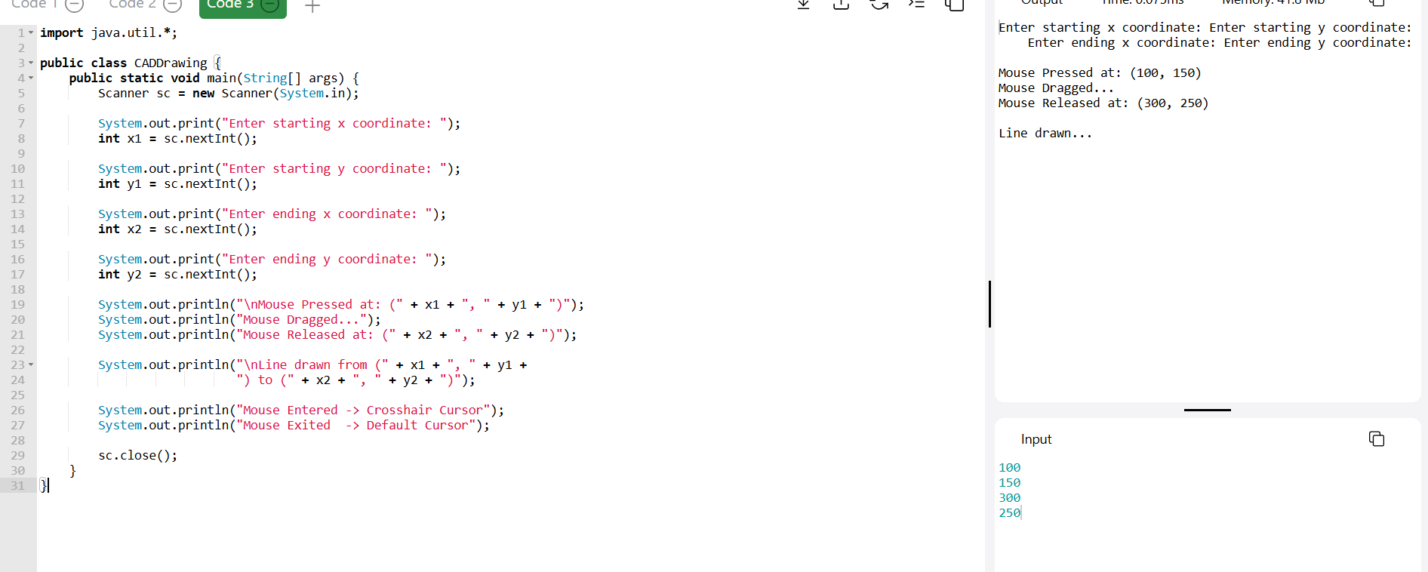
Result:
The application successfully tracks mouse press, drag, and release for drawing a line, while separately handling mouse entry and exit for cursor changes using MouseListener + MouseMotionListener.
.

